**Saturday – April 18, 2015 Lockheed-Martin Family Day**

On April 18th PHI Alpha, PHI Omega, and our Lego teams Phi Apprentice and Phi'dback, supported the Science, Technology, Engineering, and Math (STEM) outreach at the famous Lockheed-Martin SkunkWorks. We set up our practice fields in the STEM tent that we shared with another FRC team, a solar powered car team and a pilot training system Lockheed had on display. This was the first family day activity Lockheed had supported in over 10 years, they stopped having them in the past due to terrorism concerns. After setting up our fields, we had let the kids come up and drive the robot inside the field (which they had lot of fun doing), unfortunately, due to some rough handling by inexperienced underage drivers, our robot broke forcing us to halt the driving demonstrations. The driving demonstration was a huge success though, many of the kids came up and told us that they wanted to join a robotics team when they get older. We took shifts so that everyone would be able to walk around, and see the other exhibits. We saw the F-117 Stealth Fighter, a UCLASS mockup (an Unmanned, robotic, airplane for the Navy), the U-2 Spy Plane (we were able to talk to the program manager), the F-35 Stealth Fighter, and a huge, heavy lift airship they hope to sell for delivery of large items in remote areas like Arctic oil fields. In a booth next to us there were some people that talked about simulation and let us fly a simulated airplane; it was almost like a video game, it was a lot of fun, even though we did crash a few times (OK, we crashed a lot). We also had a robotics team that came up to us asking if we would come to their school and give them a presentation on FIRST Robotics and show off our robots.

**Author:** Cierra Bachtelle

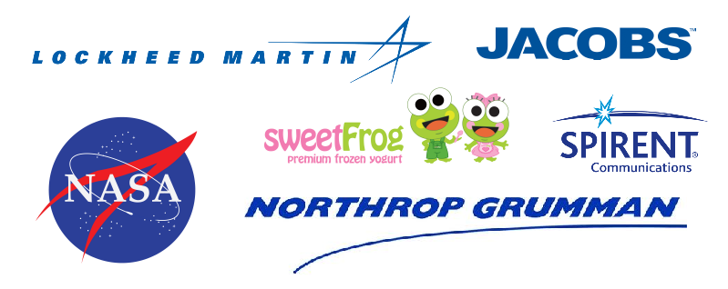

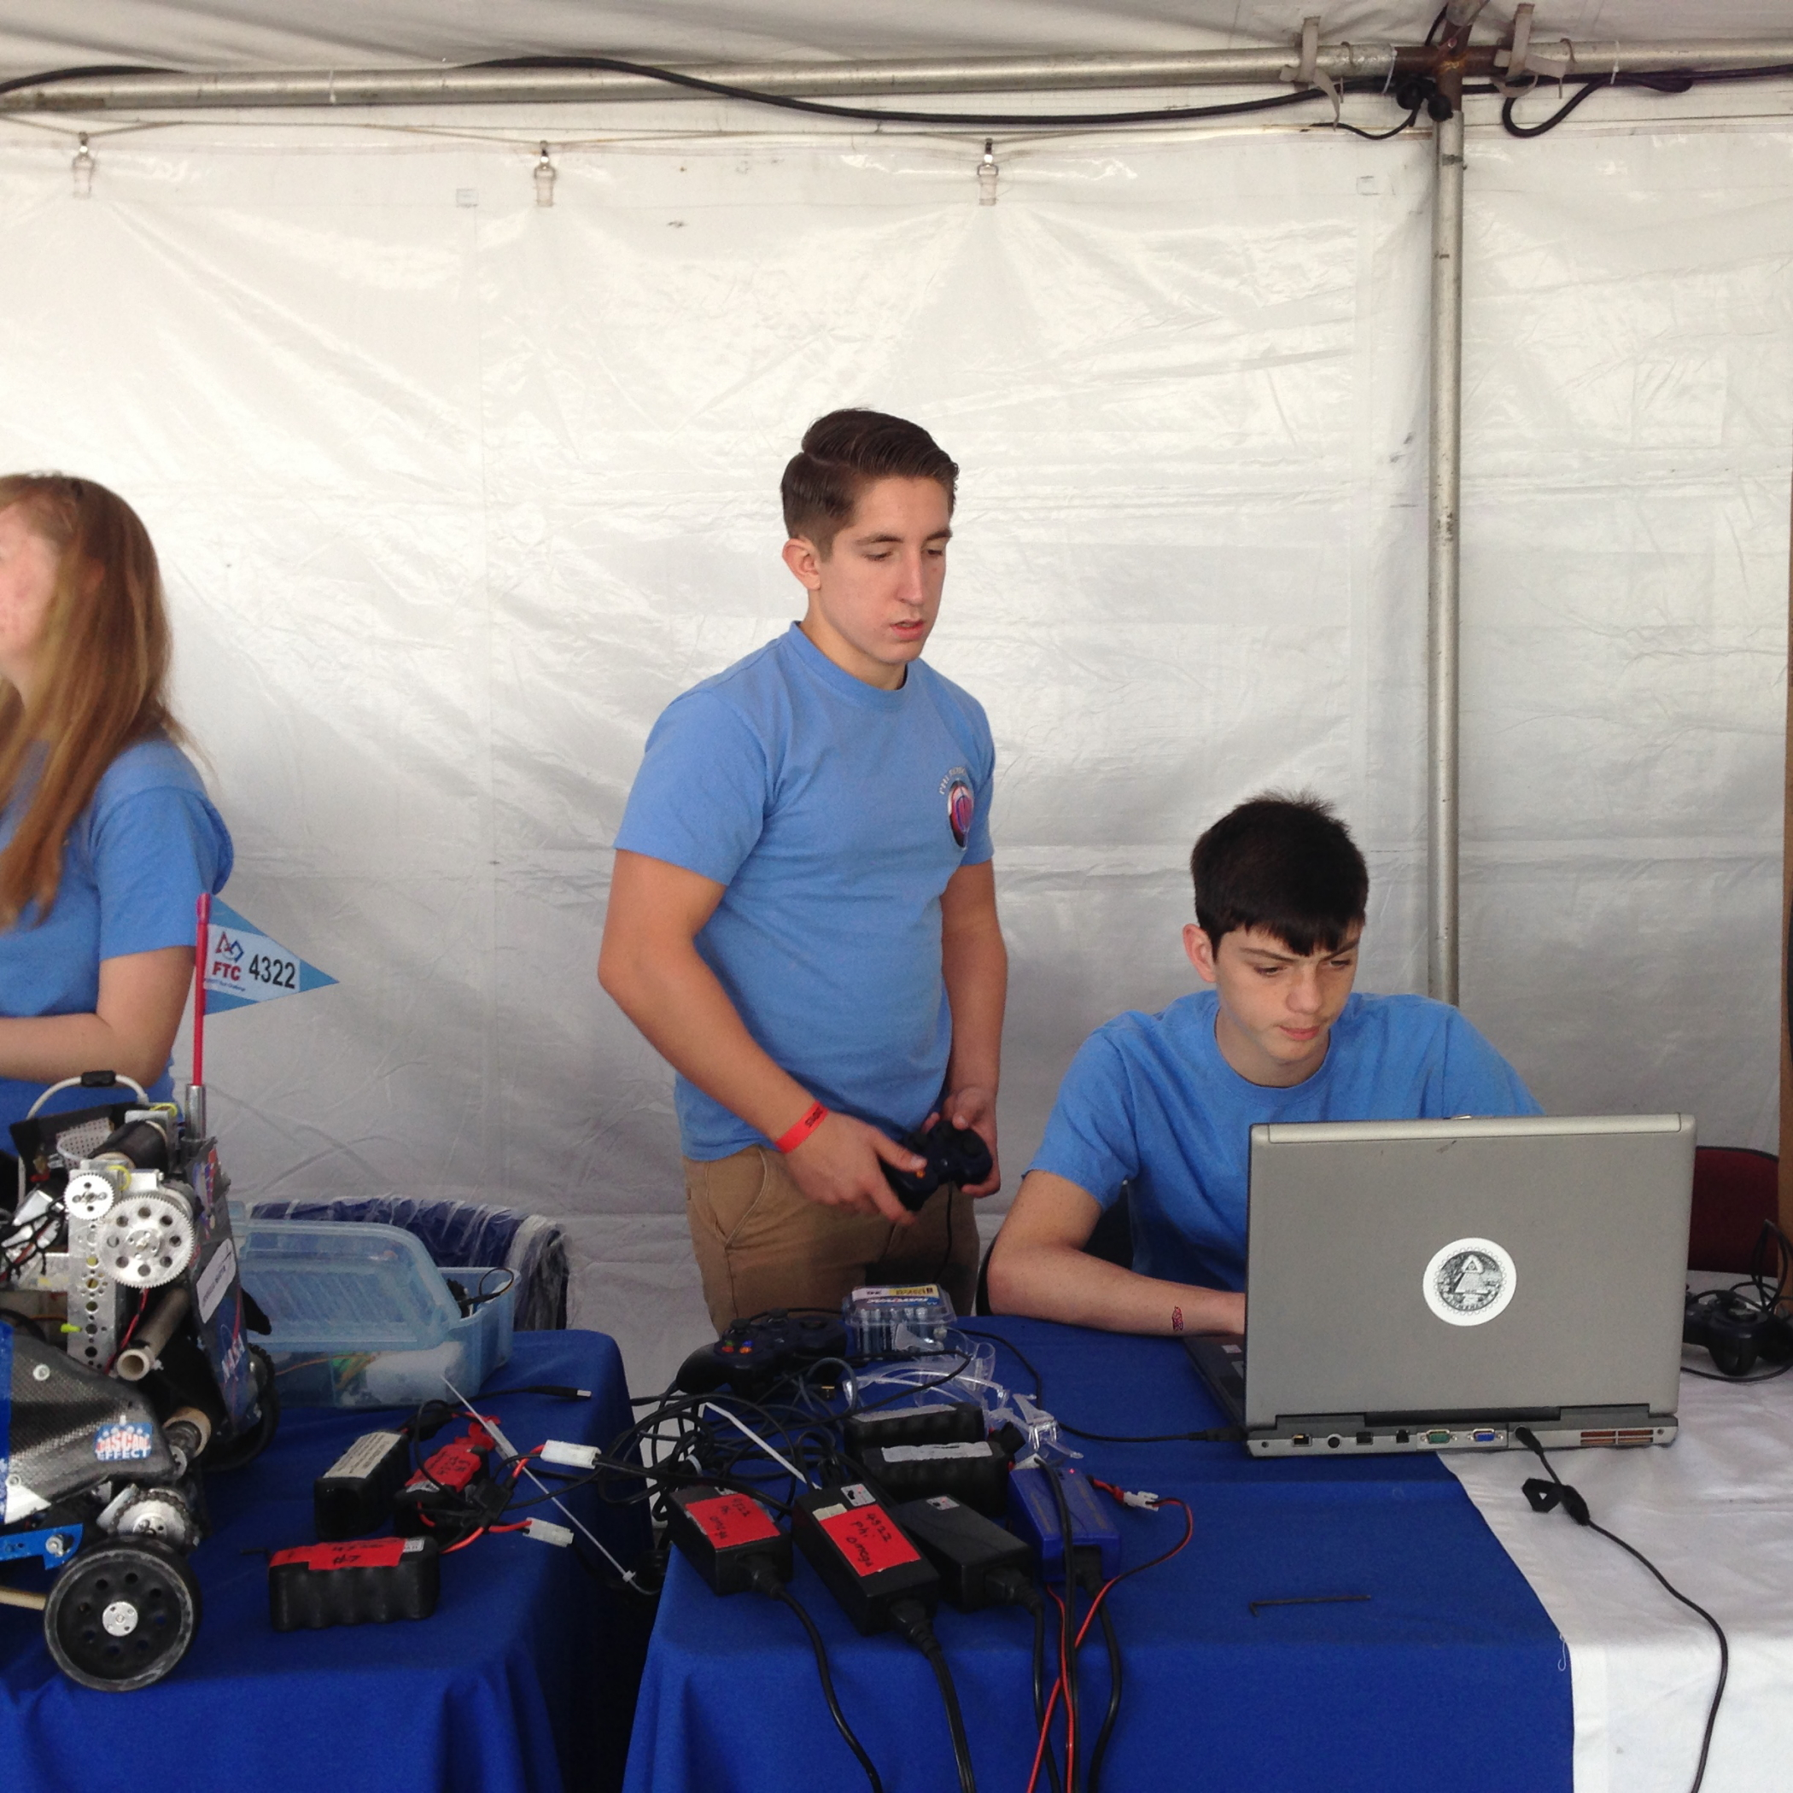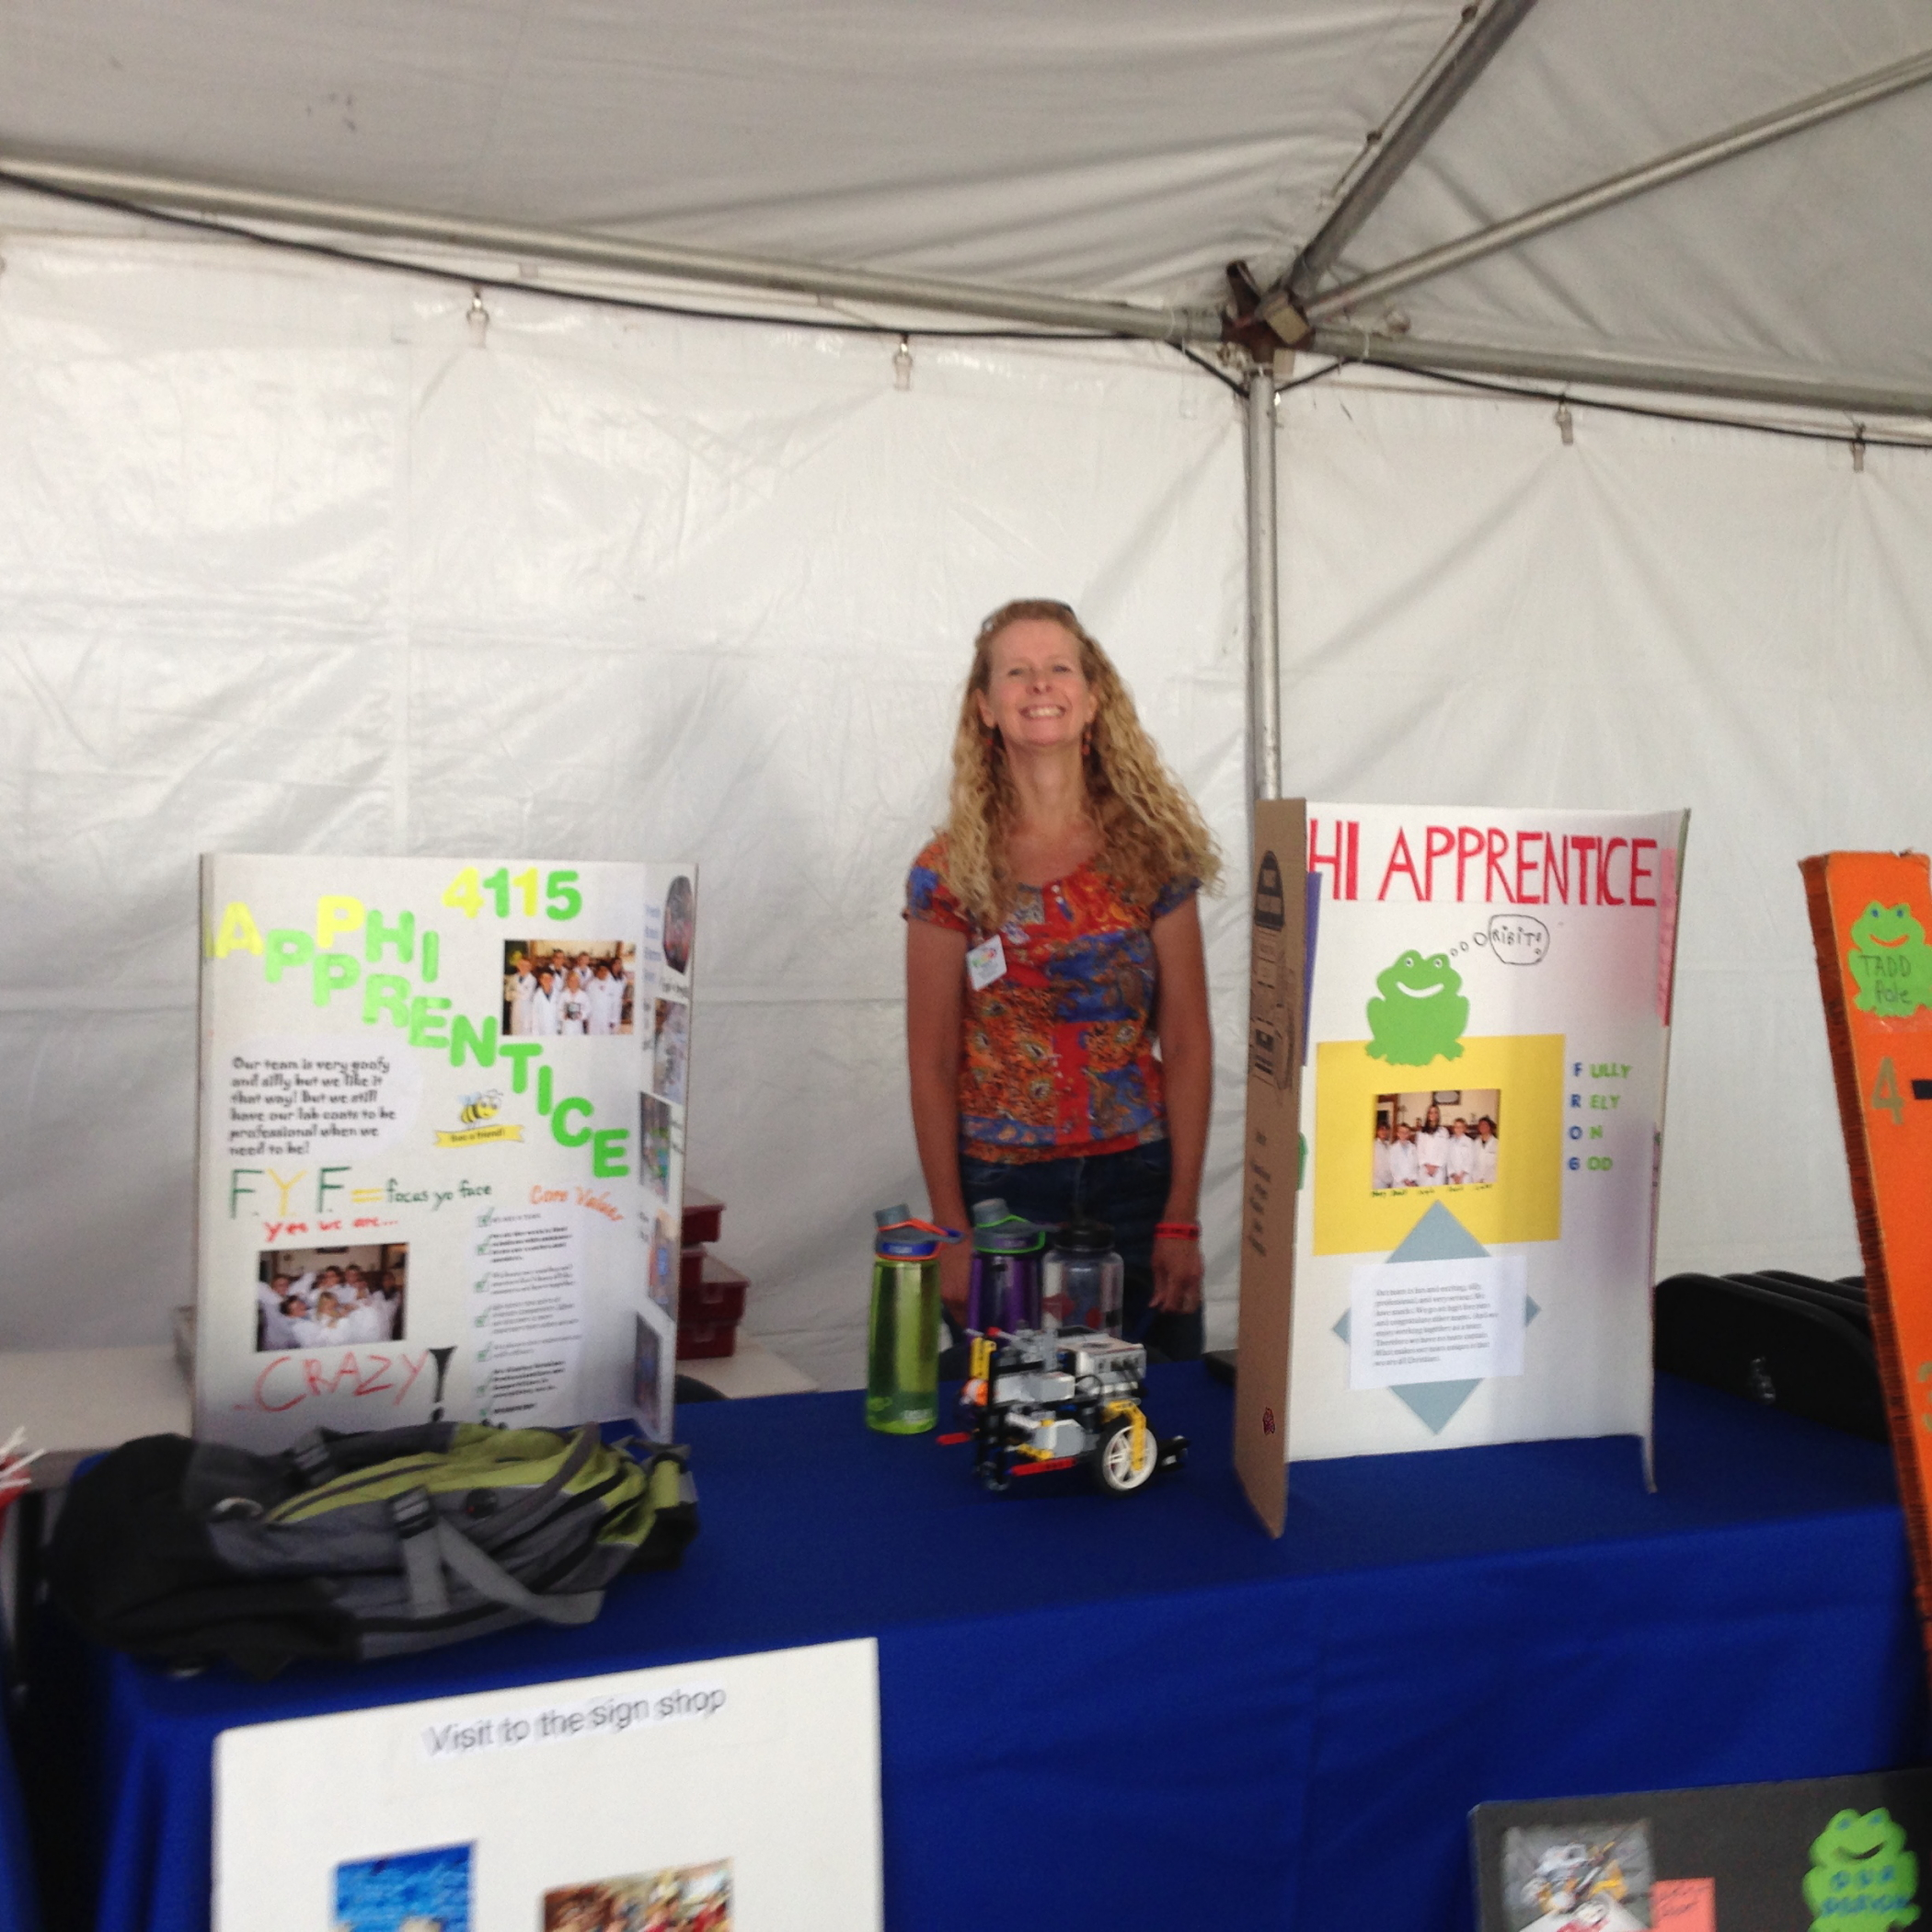

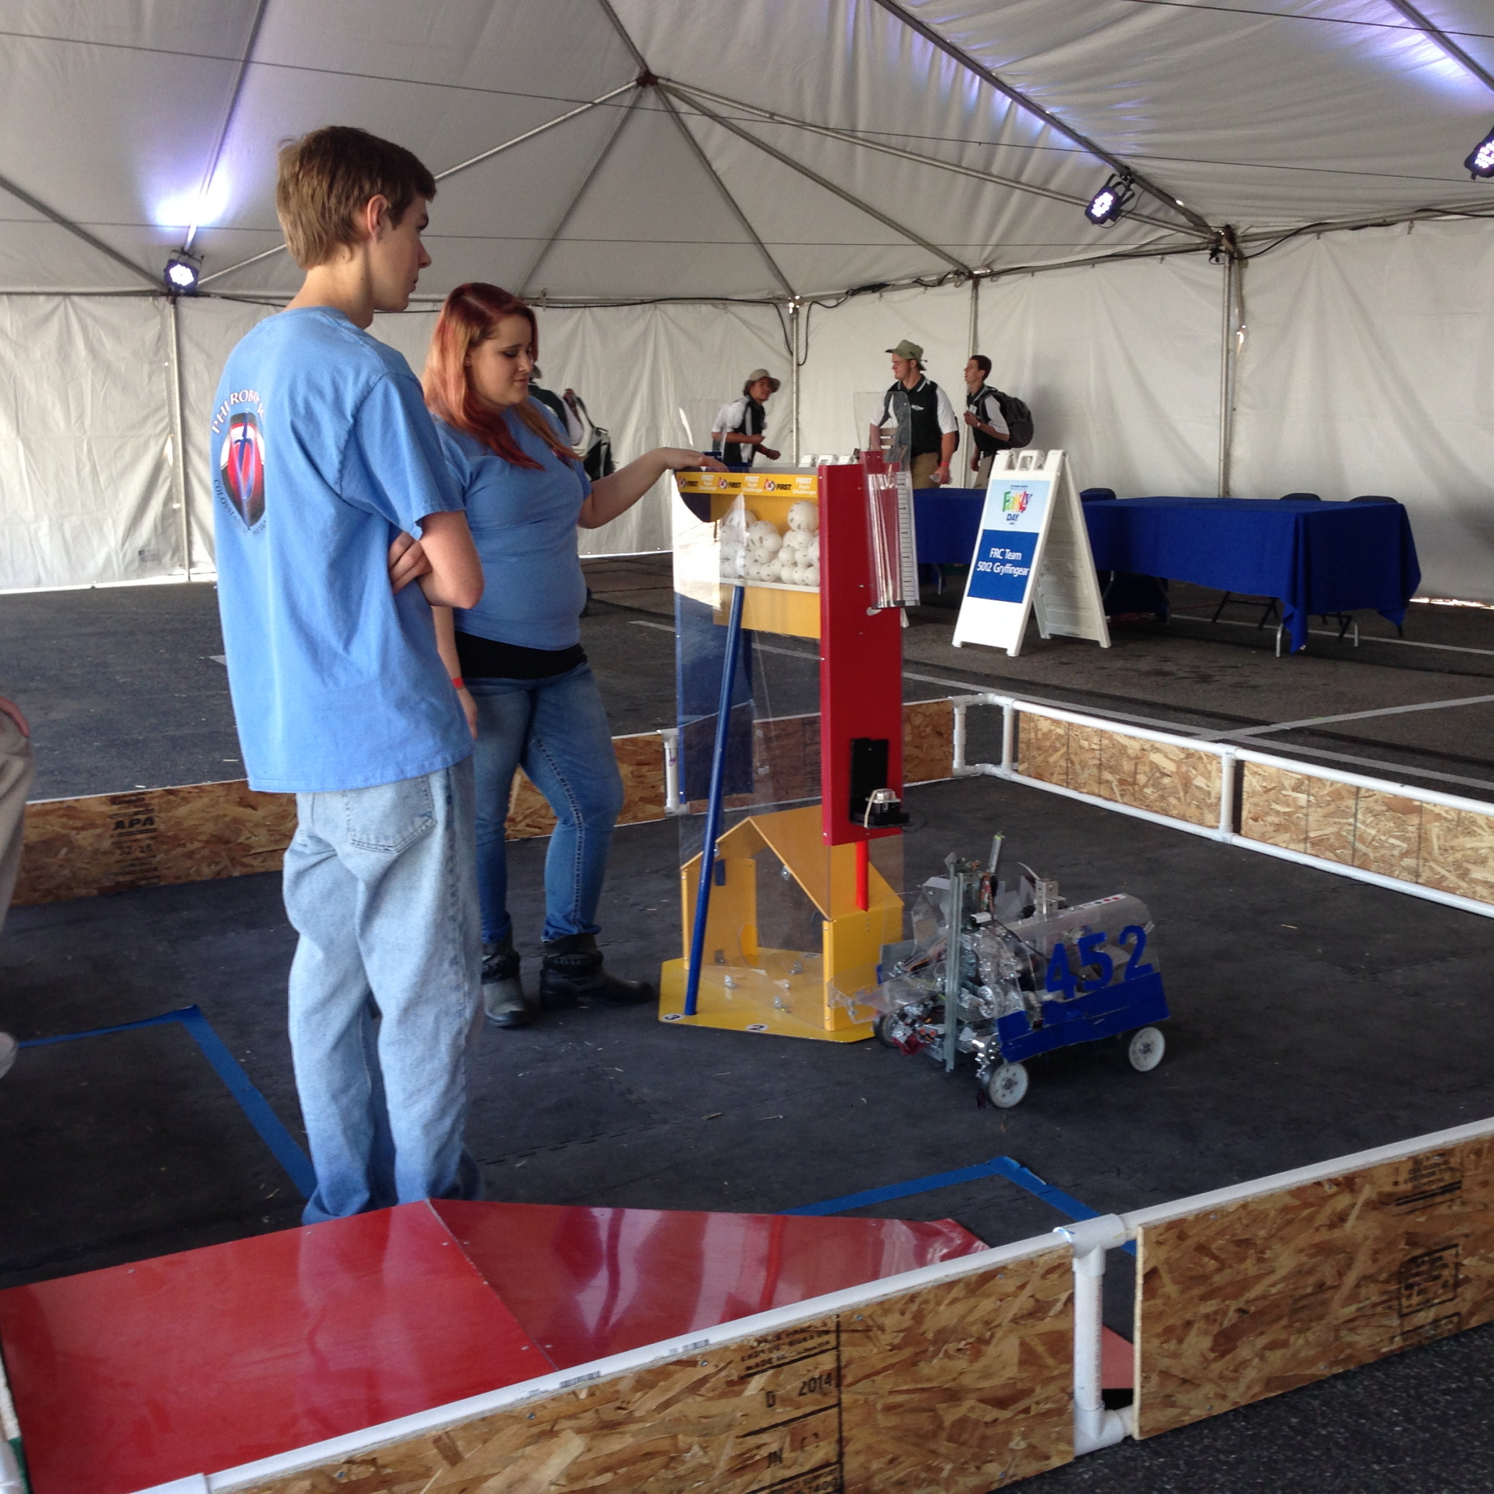

**July 22-27 2015 (A.V. Vex Workshop)**

One of several events that our team volunteered at this past summer, was the VEX Robotics workshop. The workshop was planned and executed by several FTC and FRC teams from around our area. This event was a one week long workshop, in which kids from all around the Antelope Valley would come and learn about STEM programs and engineering. Our goal was to inspire kids about engineering and to share the values that we have learned through the FIRST program.

This was done in two ways: presentations, and robot design. Each day during the beginning of workshop we had speakers come in from NASA and other engineering companies. These speakers would come in and give a short presentation about an element in engineering, such as how planes are able to fly, and then have a game set up after for them to play to give some hands on learning. For one of the presentations, all of the FIRST teams presented and spoke about their team, the game for that year, and what they went through to build their robot.

During the other part of the day, robot design, the kids were divided up into competition teams. At the beginning of the week, the kids were presented with a game challenge, similar to that in FTC. Throughout the week, the teams worked with the VEX parts to build a robot. On the final day, Saturday, parents were invited to come see their kids compete in a friendly competition. AND IT WAS LOTS OF FUN!!!!!!!!!!!!!!!!:)

**Author:** Cierra Bachtelle



**Saturday – August 22, 2015 (A.V. Fair Outreach Night)**

So on August 22nd, we went to the AV fair as one of our outreaches to our community. We brought our robots (including our Lego Mind-storm robot snake) as demonstrations and to get people interesting. We had our bots do certain tasks and go around obstacles and drive our robot around. For the snake, whenever we saw a kid come by and stop to check out the robots, we asked them if they wanted to check out our snake! The kids absolutely loved it! It has an ultra sonic sensor for the eyes and we programmed it to where whenever the ultra sonic sensor sees something it bites! So we let the snake robot slither around and let the kids put their hand in front of the eyes and it went for the bite! They jumped in surprised and were amazed! (And no it doesn’t hurt). One specific girl was afraid of snakes.. We told her how it works, we turned it off so that it doesn’t bite at her, we let her pet it first and then she got used to it and she finally let the snake playfully bite her! She was having so much fun! She conquered her fears! After we should the kids the snake, we asked them, would you be interested in robotics

and in this kind of stuff? We talked to their parents as well, they were so interested! We handed them a brochure and a number to contact. We told them how they could get their kids on a team, either through their school and if not, they have the number to get in contact and find out other options they can do. We told the parents it’s a great way to get their kids in the field in STEM (Science, Technology, Engineering, and Mathematics).

**Author:** Kayla Bachtelle

